Systolic Blood Pressure Formula Node (also outputs diastolic pressure and mean blood pressure)
sb = -9.61E-11*x⁵ + 1.25E-7*x⁴ + -5.71E-5*x³ + 1.12E-2*x² + -6.90E-1*x + 2.73E+1-sc-vv-12;
mb=0.85*sb;
db=0.7*sb;

Where: sb = systolic blood pressure
x= nonspecific variable which is influence by the global variables “VAvs VV.gv”, “Bolus number.gv”, “vclamp.gv”, “aclamp.gv”,”pumpflow.gv” and “BRCLP.gv”.
Sc = scenario which comes from Scenario 3
vv = means venovenous ECMO
The equation comes from a polynomial curve fit I did to create the relationship between systolic blood pressure and x.

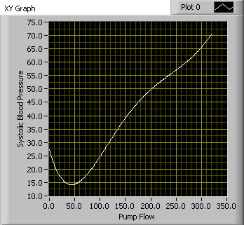

Heart Rate
y = -2.811658E-13*x⁶ + 5.146070E-10*x⁵ + -3.427709E-7*x⁴ + 1.013429E-4*x³ + -1.227369E-2*x² + 9.340113E-2*x + 2.197855E+2-36+sc;

x= nonspecific variable which is influence by the global variables “VAvs VV.gv”, “Bolus number.gv”, “vclamp.gv”, “aclamp.gv”,”pumpflow.gv” and “BRCLP.gv”.
Sc = scenario which comes from Scenario 3
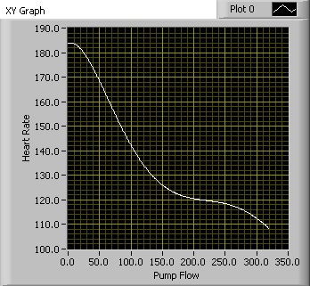

Saturation

y = 3+1.68E-18*x¹⁰ + -2.45E-15*x⁹ + 1.46E-12*x⁸ + -4.74E-10*x⁷ + 9.29E-8*x⁶ + -1.14E-5*x⁵ + 8.72E-4*x⁴ + -3.98E-2*x³ + 9.61E-1*x² + -7.55E+0*x + 1.81E+1;

x = baby PO2

Baby PO2 and CO2

o=po-300+(100*fo)+(10*ma)-120+(pf/5)-bc0;
co=pc-(dp/5)+(hz*2)-7-(pf/50)+bcc+vv;

Where:
O = baby PO2
CO = baby CO2
Po = pump O2
Fo = FIO2 from ventilator
Ma = mean airway pressure from ventilator
Pf = pump flow
Bco = bridge clamp open
Bcc = bridge clamp closed
Pc = pump CO2
Dp = delta p from ventilator
Hz = hertz from the ventilator
Vv = venoveno bypass

pH = 2.304761E-8*co**4 + -3.144806E-6*co**3 + 1.448739E-4*co**2 + -1.487887E-2*co + 7.968690E+0;

Where:
pH = baby pH
co = baby CO2

This was another curve fit equation.

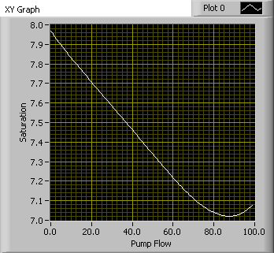

Pump Blood Gases

o=((sf+cf)+(pf/1000))*(200)+(10*s)+(bo/75);

Where:
o = pump O2
sf = sweep FIO2
cf = carbogen flow
pf = pump flow
s = sweep flow
bo = baby PO2

co=((1+(cf)-(pf/1000)-(s/2))*(35));

Where:
co = pump CO2
cf = carbogen flow
pf = pump flow
s = sweep flow

pump saturation
y = 1.68E-18*x**10 + -2.45E-15*x**9 + 1.46E-12*x**8 + -4.74E-10*x**7 + 9.29E-8*x**6 + -1.14E-5*x**5 + 8.72E-4*x**4 + -3.98E-2*x**3 + 9.61E-1*x**2 + -7.55E+0*x + 1.81E+1;

Where:
y = pump saturation
x = pupm PO2

This is also a curve fit equation.

